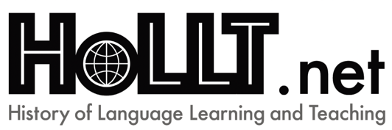
HoLLT.net (http://www.hollt.net) is a Research Network of AILA (Association Internationale de Linguistique Appliquée – International Association of Applied Linguistics) which was founded in 2015 to stimulate research into the history of language learning and teaching within applied linguistics internationally.

An international symposium on ‘Colonial contact and the history of learning and teaching non-European languages (end of the 18th – mid-20th centuries)’

Leiden University (NL), 8 June (afternoon) –10 June
Leiden University Library conference room, 2nd floor

Online presentation and participation are also possible

Call for Proposals

Although a major part of European history was, from the 16th century onwards, deeply linked to various colonial projects, the learning and teaching of non-European languages within the colonial encounter remains understudied, with the exception of missionary linguistics.
In the historiography of language learning and teaching (and the HoLLT events so far) the focus tends to be the external diffusion of European languages, usually in relation to the teaching and learning of these languages within Europe (e.g. McLelland & Smith 2014; Smith & McLelland 2018) or outside Europe (Frijhoff & Sanchez Summerer, 2016). Priority is also often given to European languages.
This HoLLT symposium intends to explore the social, political, and historical forces that mediate language ideology and practices in non-European language teaching and learning between the late 18th and mid-20th centuries.

Key Dates

By 30 April 2022 | Proposal submission:  Title of presentation  250-word abstract  5 keywords  150-word (max.) biography  Name, email address  To: HoLLTnet@gmail.com
By 6 May 2022 | Notification of acceptance
8–10 June 2022 | Symposium (at Leiden University, Netherlands) and online
15 January 2023  15 March 2023 | Draft articles due  Revised chapters due
Autumn 2023 | Publication of special issue/ volume

NB Abstracts should be written in English. Papers themselves can be presented orally in any language with appropriate textual/visual support for those unfamiliar with the language in question. Please indicate language of presentation in your submission.
There will be no registration fee. Lunch will be provided on 9th and 10th June. Participants will need to book and pay for their own accommodation and transportation.
HOLLT.net Committee:
Sabine Doff
Tim Giesler
Giovanni Iamartino
Rachel Mairs
Karène Summerer-Sanchez
Richard Smith

Organising committee:
Karène Sanchez Summerer (Chair)
Rachel Mairs (Co-Chair)
Sarah Irving

